3.2 I can identify any quality problems with web sites and how to respond to them

1. What makes a website slow

**Top 10 Reasons Your Site is Loading Slow (And steps you can take to fix it!)**



By Pabelyn Labesores

October 13th, 2021

[Performance Optimisation](https://www.eurovps.com/blog/tag/performance-optimisation/)

0 Comments

12min  read

*Ever wonder why your website is slow to load? Here are 10 of the most common reasons for slow website loading times, and also tips on how to fix it. Don’t be slow!*

You might have heard that age-old adage which says “slow and steady wins the race”, but when it comes to the performance of your website, that certainly is a recipe for failure.

**Here are our Top 10 Reasons for Slow Loading Websites.**

**1. Unoptimized Images**

A large volume of unoptimized images is usually the most common reason behind website slowness. [High-resolution images](https://www.perfocal.com/blog/photography-that-makes-your-products-look-seriously-great/) can consume lots of bandwidth while loading. Uploading larger sized images and then scaling them down can unnecessarily increase the size of your web page – causing your website to load slowly. This is true regardless of what CMS and [website builder](https://elementor.com/) you use.

The image format is another important factor to consider.

For example, JPEG images are much smaller in size compared to other image formats like PNG or GIF. Quite naturally, your web page will load faster if you are using JPEG images instead of PNG/GIF.

**Takeaways:**

* Check the file size of your images, anything above 1MB is really unacceptable.
* Use JPEG instead of PNG, especially for larger images. Icons are ok.
* Use [waterfall tests](https://tools.pingdom.com/) to easily scan image sizes and take corrective action.
* Unoptimized images can cost you money in form of bandwidth overage.
* Make sure your website is in the hands of a front-end developer, not a full-stack one. Due to the [development scope differences](https://www.scnsoft.com/services/hire-web-developers), front-end developers are usually more proficient in taming JavaScript on the client side and will skillfully solve any JS/jQuery issues.

**2. JavaScript Issues**

The availability of JavaScript/jQuery plugins has made it really convenient to add dynamic content to websites. However, if implemented incorrectly, [JavaScript](https://www.mediatraining.ltd.uk/courses/javascript-courses) can cripple your website’s page load speed.

It takes time for jQuery & JavaScript to be loaded, interpreted and executed. So if you are using multiple API calls to render JavaScript/jQuery data, it can result in significant delay while loading the web pages.

**Takeaways:**

* Script bloat is real. [Audit your JavaScript](https://asperbrothers.com/blog/technical-seo-audit/) scripts to see what you really need and remove what you don’t.
* Asynchronous loading is a must.
* Consider using something like Segment or Google Tag Manager. A single script for all your tools!

**3. Too Much Flash Content**

Although Flash is a great tool for adding interactivity to your website, it is highly likely contributing to your slow page load speed. Flash content is usually bulky in size and the bigger the file size is, the slower your pages will load.

Reducing the size of your Flash files or eliminating it altogether would improve your page loading speed significantly. If you are willing to [make your website faster](https://gigsdoneright.com/how-to-optimize-website-for-mobile/), you should look for HTML5 alternatives to replace your existing Flash content.

**Takeaways:**

* Flash is very bulky and is not good for performance.
* Flash used to be cool. It’s not anymore.
* Look for HTML5 replacements.

**4. Excessive HTTP Requests**

Having loads of JavaScript, CSS, and image files can lead to too many HTTP requests. When a user visits your web page, the browser performs several requests to load each of these files – which can significantly reduce the page load speed.

**Takeaways:**

* Use [Sprites](http://peterkeating.co.uk/reducing-http-requests-for-images-using-css-sprites/) to reduce HTTP requests.
* Reduce the number of files on your pages where possible. Includes CSS, images, javascript.
* Minify your CSS and Javascript files reduces # of total files users will have to download.

**5. Not Making Use of Caching Techniques**

[Caching](https://www.eurovps.com/blog/understanding-php-caching) is known to improve the performance of websites by leaps and bounds. If you’re not caching, you’re missing out. It’s a technique that let’s you store frequently used data points in the ‘cached memory’.

Any subsequent requests for the same content gets served from the cached memory, thus speeding up the whole data retrieval process.

By implementing browser/HTTP caching and server-side caching, you are likely to experience a huge improvement [in the performance of your website](https://onlinebizbooster.net/website-kpis-how-to-measure-your-websites-performance/).

**Takeaways:**

* Caching drastically improves performance.
* You can cache a bunch of things from HTTP, Database Queries, to images.
* If you can cache something, do it. But do it carefully so you don’t mess something up. It can be tricky.

**6. Unclean Code**

Another common culprit for website slowness is unclean coding. When you [make your website](https://firstsiteguide.com/make-website/), excessive white spaces, inline stylings, empty new lines and unnecessary comments can make the website stylesheet grow larger in size.

By removing these unnecessary elements, you can compress the code, reduce the file size and improve the overall page load time and if you’re [tracking rankings](https://nightwatch.io/) you’ll probably see a [boost in your SEO performance](https://userp.io/organic-business-growth/) too. In technical terms, this process is known as minifying. If you are not comfortable with coding, there are several online tools that can be used to clean and minify your stylesheet files. Alternatively, you can use a helping hand of some [IT services providers.](https://totalityservices.co.uk/)

**Takeaways:**

* Attention to detail matters.
* Don’t be lazy and use inline CSS
* Try not to create multiple CSS stylesheets when you can use a single one.
* Minify!

**7. Not Using gZIP Compression**

By enabling gZIP compression, you [instruct the server](https://diggitymarketing.com/reduce-server-response-time/) to wrap all the web objects (images, CSS, JavaScript files etc) in a single container before they are sent over to the requesting browser.

Compression lowers response time by reducing the size of data being transferred between your server and the visitors’ browser, which in turn helps in serving the requested content much faster.

If you are yet to enable gZIP compression on your website, then it’s the first thing you should do without wasting any further time.

**Takeaways:**

* gZIP compression is an easy performance win.
* It wraps up all your web objects (images, CSS, jS) in a single container to be sent to requesting browser

**8. Too Many Ads**

No doubt [display advertisements](https://avada.io/resources/display-advertising.html) are great for monetizing high traffic websites and increase results on your [advertising report](https://whatagraph.com/advertising-report).

But that shouldn’t come at the cost of compromised performance or user experience. Don’t let too many ads be another reason why your website is slow!

The most obvious impact of overloading your website with advertisements is the addition of HTTP requests, which would need additional processing time.

Especially the rich media ads – like pop unders, interstitials and auto downloads – may create hundreds of HTTP requests making your website unresponsive.

To sum things up, limiting the number of display advertisements will ensure better performance for your website.However, there may be some creative options outside of limiting ads. The team at gaming site [Solitaired](https://solitaired.com/" \t "_blank), for example, experimented with loading ads based on a timed delay on when users started playing their solitaire game. As a result, page speed improved and they were able to maintain ad revenue.

**Takeaways:**

* Advertisements are additional HTTP requests and slow down page loading time.
* Use them only where you need to, it will improve performance, UX, and [CTR’s to your ads](https://sixads.net/blog/shopify-dropshipping-success-from-0-to-1k-day/).

**9. Not Using a CDN Service**

A CDN service is a distributed network of independent servers deployed in different geographic locations, that can serve web content to visitors with high availability and high performance.

Depending upon the geographic location of your visitor, the requested content gets served by the node located at the nearest available data center. It would minimize the round-trip-time (RTT) and serve the requested content in a much quicker time.

**Takeaways:**

* Not mandatory, but CDN can help. Especially if you have visitors from around the world.
* CDN caches frequently accessed data in geographically distributed datacenters.
* They can help minimise round-trip-time (RTT) and serve content faster [for your audiences](https://instasize.com/blog/5-fundamentals-to-boost-your-customer-focus).

**10. Bad Hosting**

Your web hosting service provider makes a huge difference when it comes to website performance. Yes, your slower-than-average page load speed may not be entirely your own fault.

If you have tried correcting all the above-mentioned causes and yet your website seems to be responding slowly, then switching your hosting provider may just solve your problem. [Choose a hosting provider](https://www.founderjar.com/best-web-hosting-services/) that offer performance optimisation services bundled in the price of the hosting.

[Real managed hosting](https://www.eurovps.com/mino-hosts) should include this.

For example at EuroVPS, we offer custom web servers, built for each client individually and according to his web site’s needs. We know how each tool will best interface with the most popular scripts on the market today,including Drupal, WordPress, Expression Engine, Joomla and more.

[Slow loading websites](https://andriy.space/fix-slow-wordpress-admin/) shouldn’t “be a thing” if your hosting provider knows what they are doing.

**Conclusion**

Website page load speed depends on a variety of factors such as unoptimized images, a high number of HTTP requests, bulky codes, and JavaScript issues to name a few.

It can be a difficult task to figure out what exactly is causing the website to slow down. No matter what the root cause might be, you should leave no stones unturned to get to the bottom of the issue because failure to do so could be the difference between an additional [$1000/month in revenue](https://www.onehourprofessor.com/make-extra-1000-a-month/).

At EuroVPS, our Support team will help you get rid of slow loading websites for good. We’ll help you adjust Apache parameters, PHP configurations & versions, as well as even compile custom Apache/PHP stacks upon request.

2. How to speed a web site

**2.22222222222222222222222222222222222222222  
How to fix a slow loading website and get closer to 100% GTmetrix**

* [6 Comments](https://onlinemediamasters.com/website-loading-slow/#comments)
* A person wearing a hat

  Description automatically generated with medium confidence
* [Tom Dupuis](https://onlinemediamasters.com/about-us/)
* Last Updated: January 23, 2022

Have a slow website?

If your website is loading slow, you can speed it up by using faster hosting, page builders, plugins, and images. Configuring a caching solution and CDN should also help, plus optimizing third party scripts like Google Fonts. Finally, make sure to clean you database and use PHP 7.4.

What if I told you my website loads in <1s with [100% GTmetrix scores](https://gtmetrix.com/reports/onlinemediamasters.com/lCtKx0c3/)? And that I’ve already written one of the most popular [WordPress speed guides](https://onlinemediamasters.com/slow-wordpress-site/) online with over 400 comments?

Some optimizations are specific to WordPress, others are universal. But they are all best practice even if you’re using Squarespace, Shopify, Wix, and other website building platforms.

**How to fix a slow loading website**

1. [Test Your Website In GTmetrix](https://onlinemediamasters.com/website-loading-slow/#gtmetrix)
2. [Resize Large Images](https://onlinemediamasters.com/website-loading-slow/#resize-large-images)
3. [Compress Images](https://onlinemediamasters.com/website-loading-slow/#compress-images)
4. [Add Caching](https://onlinemediamasters.com/website-loading-slow/#caching)
5. [Upgrade To PHP 8.0](https://onlinemediamasters.com/website-loading-slow/#php)
6. [Check Server Response Times](https://onlinemediamasters.com/website-loading-slow/#server-response-time)
7. [Move To Cloud Or LiteSpeed Hosting](https://onlinemediamasters.com/website-loading-slow/#hosting)
8. [Add Cloudflare’s CDN](https://onlinemediamasters.com/website-loading-slow/#cloudflare)
9. [Disable Hotlinking](https://onlinemediamasters.com/website-loading-slow/#hotlinking)
10. [Minify Files](https://onlinemediamasters.com/website-loading-slow/#minify-files)
11. [Combine Files](https://onlinemediamasters.com/website-loading-slow/#combine-files)
12. [Avoid Heavy Plugins](https://onlinemediamasters.com/website-loading-slow/#heavy-plugins)
13. [Clean Your Database](https://onlinemediamasters.com/website-loading-slow/#clean-database)
14. [Optimize External Resources](https://onlinemediamasters.com/website-loading-slow/#external-resources)
15. [Combine Google Fonts](https://onlinemediamasters.com/website-loading-slow/#combine-fonts)
16. [Lazy Load Images + Videos](https://onlinemediamasters.com/website-loading-slow/#lazy-load)
17. [Avoid Advertisements](https://onlinemediamasters.com/website-loading-slow/#advertisements)
18. [Consider AMP](https://onlinemediamasters.com/website-loading-slow/#accelerated-mobile-pages)
19. [Find Slow Pages In Google Analytics](https://onlinemediamasters.com/website-loading-slow/#slow-pages)
20. [WordPress-Specific Optimizations](https://onlinemediamasters.com/website-loading-slow/#wordpress)
21. [WooCommerce Optimizations](https://onlinemediamasters.com/website-loading-slow/#woocommerce)
22. [Hire Someone Who Knows What They’re Doing](https://onlinemediamasters.com/website-loading-slow/#hire-a-speed-optimizer)
23. [Frequently Asked Questions](https://onlinemediamasters.com/website-loading-slow/#faq)

**1. Test Your Website In GTmetrix**

[GTmetrix](https://gtmetrix.com/) shows you:

* **Load time** (primary metric)
* Which [**images**](https://gtmetrix.com/blog/how-to-optimize-images-a-practical-guide/) need to be optimized
* Which **plugins** are loading slow (check the Waterfall tab)
* Your **time to first byte** (indicates the speed of your hosting)
* Whether your **cache plugin** is doing it’s job (I recommend WP Rocket)
* Whether you’re using a **content delivery network** (I recommend Cloudflare)
* Slow loading **external resources** (AdSense, Maps, YouTube/Facebook embeds)

**Quick Fixes?**  
Hosting is the #1 factor in the [official WordPress optimization guide](https://wordpress.org/support/article/optimization/) (by far). It may not improve GTmetrix scores, but it can improve load times by multiple seconds especially if you go from a slow host (Bluehost, HostGator, GoDaddy) to a fast host ([Cloudways](https://www.cloudways.com/en/online-media-masters.php?id=262128" \t "_blank)). They were rated highest in recent [Facebook polls](https://onlinemediamasters.com/siteground-wordpress-hosting-review/#polls) I collected from multiple WordPress Facebook Groups, and who I use.

Cache plugins have the biggest impact on scores and also improve load times. [WP Rocket](https://onlinemediamasters.com/go/wp-rocket/) is better than W3 Total Cache or WP Fastest Cache as it has more [features](https://onlinemediamasters.com/go/wp-rocket-features/) (like lazy loading, database cleanup, and Google Font + Analytics optimization) while other cache plugins do not.

**WordPress Speed Video Tutorial**  
If you’re using WordPress, I spent many hours creating this 28 minute video on speed up WordPress sites. You can use timestamps in the video description to jump to specific sections.

Here’s my GTmetrix report. 1.3s load times are fast when you have a 2.56MB page size, 89 requests, 400+ comments while showing Gravatars, over 70 images, and an embedded video.

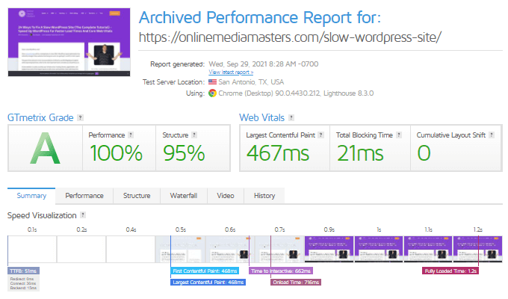

*Even long posts with tons of images and 600 comments still load in about 1s with a 51ms TTFB*

**2. Resize Large Images**

This is what [serve scaled images](https://gtmetrix.com/serve-scaled-images.html) means in GTmetrix.

It means you’re uploading large images with incorrect dimensions. Each section of your website has specific dimensions (sliders, thumbnails, carousel, fullwidth and sidebar images).

For example, I know my blog’s content body is 680 pixels in width. Any fullwidth images I use for my blog should always be resized to those dimensions.

GTmetrix shows you all unoptimized images (and the correct dimensions they should be resized to) but only for the single page you test. All you have to do is resize those images and replace the old version with the new one.

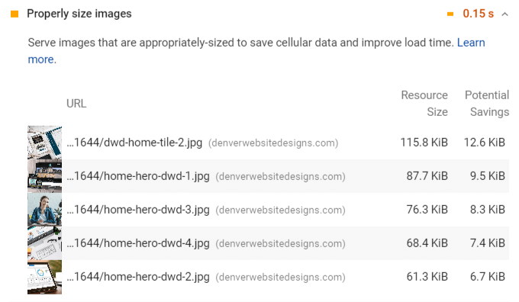

**Bonus: create a cheat sheet** – write down all the different images sizes on *your* website.

* Logo: 200 x 58px
* Favicon: 16 x 16px
* Sliders: 1903 x 400px
* Carousel images: 115px
* Widget images: 420 x 250px
* Featured images: 250 x 250px
* Fullwidth blog post images: 680px
* Yoast Twitter OG Image: 1024 x 512px
* Yoast Facebook OG Image: 1200 x 630px

[Squarespace](https://support.squarespace.com/hc/en-us/articles/206542517-Formatting-your-images-for-display-on-the-web), [Wix](https://support.wix.com/en/article/recommended-image-sizes-for-the-new-wix-blog" \t "_blank), and WordPress themes should include instructions for resizing images.

**3. Compress Images**

This is what [optimize images](https://gtmetrix.com/optimize-images.html) means in GTmetrix.

There are many tools to do this (I use the ShortPixel WordPress plugin). Be sure to **remove**[**EXIF data**](https://en.wikipedia.org/wiki/Exif) to make images load even faster, which can also be done in some of the tools below.

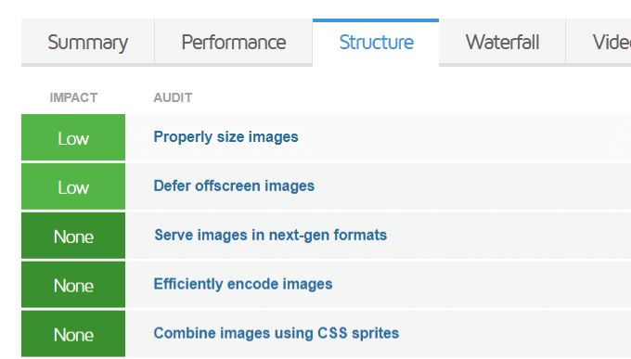

**Image Compression Tools**

* [Photoshop](https://helpx.adobe.com/photoshop/key-concepts/compression.html)
* [GIMP](https://docs.gimp.org/2.10/en/gimp-tutorial-quickie-jpeg.html)
* [ShortPixel](https://shortpixel.com/)
* [JPEGmini](https://www.jpegmini.com/)
* [TinyPNG](https://tinypng.com/)
* [Smush](https://wordpress.org/plugins/wp-smushit/)
* [Compressor](https://compressor.io/)

**Will I Lose Quality?**  
Even if you choose lossless compression, you might notice a small loss in quality. That’s why it’s best to test a couple images beforehand, and take a backup if you’re bulk optimizing all images.

**4. Add Caching**

If you’re **not using WordPress**, your platform should take care of [caching](https://varvy.com/pagespeed/leverage-browser-caching.html), minification, combining files, and other optimizations in GTmetrix that would usually require a plugin.

If you’re using **WordPress**, ask yourself:

* Are you using a cache plugin?
* Which cache plugin are you using?
* Have you configured it to the optimal settings?

These 3 factors will have the highest impact on your scores in GTmetrix, Google PageSpeed Insights, and pretty much any speed testing tools. Caching and hosting are super important!

**Which Cache Plugin Is Best?**  
I recommend [WP Rocket](https://onlinemediamasters.com/go/wp-rocket/) which is a premium cache plugin. It comes with many features other cache plugins don’t (database cleanup, heartbeat control, lazy loading, optimization of Google Fonts + Analytics, CDN integration). If you wanted to use these features with other cache plugins, you would need to install about 6 extra plugins to take care of these optimizations, while WP Rocket has everything built-in. The closest free cache plugin that do these is Swift.

WP Rocket was also rated #1 in multiple Facebook polls:

[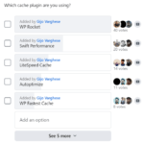](https://cdn.onlinemediamasters.com/wp-content/uploads/2021/01/Cache-Plugin-Poll-680.png)

[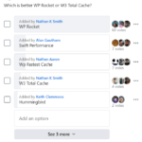](https://cdn.onlinemediamasters.com/wp-content/uploads/2021/01/WP-Rocket-vs.-W3-Total-Cache.png)

[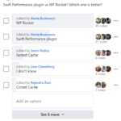](https://cdn.onlinemediamasters.com/wp-content/uploads/2021/01/Swift-Performance-vs-WP-Rocket.png)

[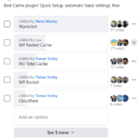](https://cdn.onlinemediamasters.com/wp-content/uploads/2021/01/Best-cache-plugin-facebook-poll.png)

[](https://cdn.onlinemediamasters.com/wp-content/uploads/2021/01/Cache-Plugin-Facebook-Poll-680.png)

[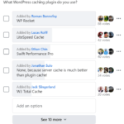](https://cdn.onlinemediamasters.com/wp-content/uploads/2021/01/What-cache-plugin-do-you-use.png)

[](https://cdn.onlinemediamasters.com/wp-content/uploads/2021/01/Best-cache-plugin-poll.png)

[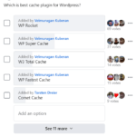](https://cdn.onlinemediamasters.com/wp-content/uploads/2021/01/Best-cache-plugin-for-WordPress.png)

**5. Upgrade To PHP 8.0**

This only applies if you bought hosting (eg. SiteGround, Bluehost, GoDaddy).

[Upgrading to PHP 7+](https://kinsta.com/blog/php-benchmarks/) is very simple and should make a significant impact on load times.

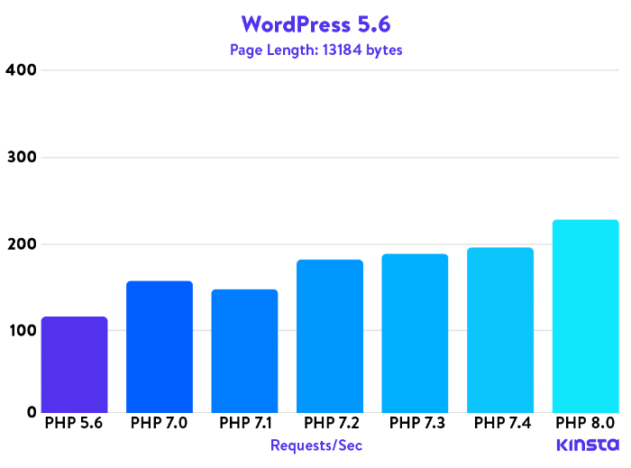

**Step 1**: Login to your hosting account and find the PHP version manager (or similar).

**Step 2**: Upgrade to the highest PHP version available on your hosting account (i.e. PHP 8.0).

**Step 3**: Test your website for errors. If you see any, it’s probably due to incompatible WordPress plugins, in which case you can use [PHP Compatibly Checker](https://wordpress.org/plugins/php-compatibility-checker/). This tool will show you incompatible plugins; you should either delete them, or revert to an earlier PHP version.

**Step 4**: Keep your PHP version current. If your host releases a new stable PHP version, use it.

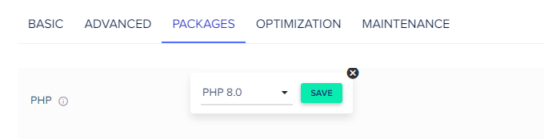

**6. Check Server Response Times**

[Google PageSpeed Insights](https://pagespeed.web.dev/) tells you if you have a slow [server response times](https://web.dev/time-to-first-byte/) (Google recommends it should be under 200ms). Servers are obviously controlled by your hosting.

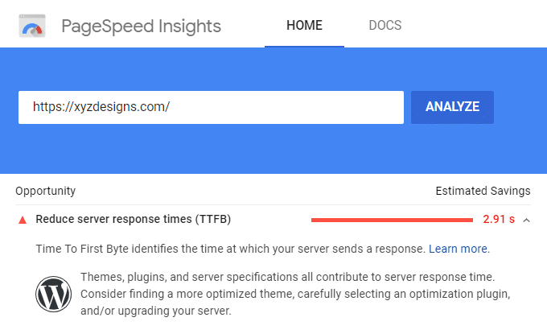

**How To Improve Server Response Time**

* Get better hosting (eg. Cloudways)
* Stay away from [EIG hosts](https://en.wikipedia.org/wiki/Endurance_International_Group) who are infamously slow
* Make sure you have caching enabled on your website
* Use a content delivery network like Cloudflare’s CDN
* Eliminate all heavy and unused plugins on your website
* Use a premium DNS provider (get this through your host)

**7. Move To Cloud Or LiteSpeed Hosting**

Most hosting recommendations are garbage.

SiteGround has a [slow TTFB](https://backlinko.com/page-speed-stats#ttfb-and-hosting), GoDaddy is a [NO](https://cdn.onlinemediamasters.com/wp-content/uploads/2018/06/GoDaddy-WordPress-Hosting-Feedback.png), Bluehost is [gangrene](https://cdn.onlinemediamasters.com/wp-content/uploads/2020/10/Speed-Up-Slow-Bluehost.png), and [stay away](https://cdn.onlinemediamasters.com/wp-content/uploads/2021/12/Hostinger-Review-Poll.png) from Hostinger. Most hosting recommendations are garbage and I suggest joining the [WP Speed Matters Facebook Group](https://www.facebook.com/groups/1518060691663542) (run by Gijo Varghese) to get unbiased feedback on speed/hosting.

I use [Cloudways Vultr HF](https://www.cloudways.com/en/online-media-masters.php?id=262128" \t "_blank) which is a [popular choice](https://cdn.onlinemediamasters.com/wp-content/uploads/2021/12/Cloudways-Facebook-Group-Feedback.png) in Facebook Groups. You can check my [GTmetrix report](https://gtmetrix.com/reports/onlinemediamasters.com/lCtKx0c3/" \t "_blank), TTFB, or click through my site to see yourself. I moved from SiteGround to Cloudways which [cut load times in half](https://cdn.onlinemediamasters.com/wp-content/uploads/2020/07/Cloudways-Shoutout.png) and fixed CPU issues (it’s also monthly pricing with no higher renewals). They use Object Cache Pro/Redis with NVMe storage and 44 data centers. Main cons are no file manager/email hosting and their Breeze plugin + CloudwaysCDN aren’t great. I suggest WP Rocket or FlyingPress, Cloudflare or BunnyCDN, and Google Workspace. They do 3-day trials, a [free migration](https://support.cloudways.com/how-to-request-a-managed-application-migration-to-cloudways/?id=262128), and a [promo code](https://www.cloudways.com/en/online-media-masters.php?id=262128) for 30% off 3 months. Some people are afraid they’re techie since it requires an extra step to [launch a Vultr HF server](https://support.cloudways.com/how-to-launch-a-new-application-on-a-new-server/?id=262128), but it’s not hard:





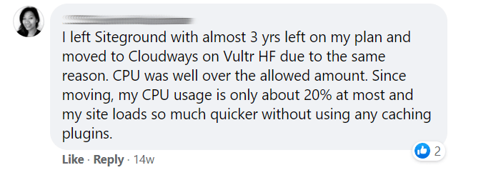



Spend 5 minutes looking at recent Facebook polls on “the best hosting,” migration results of people who switched, and [unbiased feedback](https://cdn.onlinemediamasters.com/wp-content/uploads/2021/05/Cloudways-Vultr-HF-Feedback.png) in Facebook groups (**click thumbnails to enlarge**).



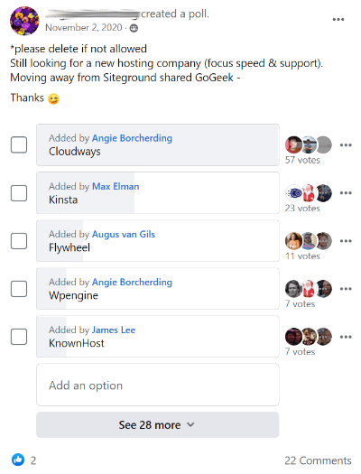

[](https://cdn.onlinemediamasters.com/wp-content/uploads/2021/10/Best-SiteGround-Alternative.png)

[](https://cdn.onlinemediamasters.com/wp-content/uploads/2021/10/Reliable-fast-hosting.png)

[](https://cdn.onlinemediamasters.com/wp-content/uploads/2021/10/eCommerce-Hosting-Poll.png)

[](https://cdn.onlinemediamasters.com/wp-content/uploads/2021/10/Favorite-Premium-Web-Host.png)

[](https://cdn.onlinemediamasters.com/wp-content/uploads/2021/10/Cloudways-vs-Plesk-vs-Cyberpanel.png)

[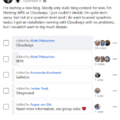](https://cdn.onlinemediamasters.com/wp-content/uploads/2021/10/WPX-vs-Cloudways.png)

[](https://cdn.onlinemediamasters.com/wp-content/uploads/2019/03/Cloud-Hosting-Poll.png)

[](https://cdn.onlinemediamasters.com/wp-content/uploads/2021/10/Elementor-Hosting-Poll.png)

[](https://cdn.onlinemediamasters.com/wp-content/uploads/2021/10/Shared-Managed-Hosting-Suggestions.png)

[](https://cdn.onlinemediamasters.com/wp-content/uploads/2021/10/Exploring-new-hosting-options.png)

[](https://cdn.onlinemediamasters.com/wp-content/uploads/2021/10/Hosting-Poll-2019.png)

[](https://cdn.onlinemediamasters.com/wp-content/uploads/2021/10/VPS-Cloud-Hosting-Poll.png)

[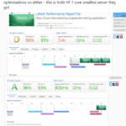](https://cdn.onlinemediamasters.com/wp-content/uploads/2021/05/SiteGround-vs-Cloudways-Vultr.png)

](https://cdn.onlinemediamasters.com/wp-content/uploads/2021/12/SiteGround-to-Cloudways-Jump.png)

[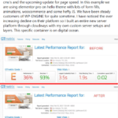](https://cdn.onlinemediamasters.com/wp-content/uploads/2021/10/WP-Engine-to-Cloudways-Switch.png)

[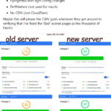](https://cdn.onlinemediamasters.com/wp-content/uploads/2021/10/DigitalOcean-to-Vultr-HF.png)

[](https://cdn.onlinemediamasters.com/wp-content/uploads/2020/10/Kinsta-vs-Cloudways-Speed.png)

[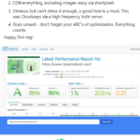](https://cdn.onlinemediamasters.com/wp-content/uploads/2021/10/Cloudways-With-Divi.png)

[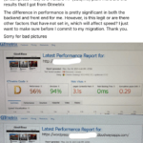](https://cdn.onlinemediamasters.com/wp-content/uploads/2022/01/Dreamhost-to-Cloudways-Vultr.png)

[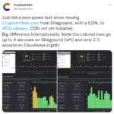](https://cdn.onlinemediamasters.com/wp-content/uploads/2021/10/SiteGround-to-Cloudways-Move.png)

[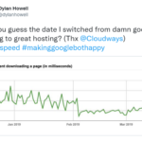](https://cdn.onlinemediamasters.com/wp-content/uploads/2021/10/Cloudways-Switch-Hosting.png)

[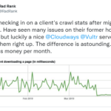](https://cdn.onlinemediamasters.com/wp-content/uploads/2021/10/Cloudways-Vultr-Migration.png)

[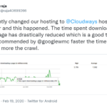](https://cdn.onlinemediamasters.com/wp-content/uploads/2021/10/Change-hosting-to-Cloudways.png)

[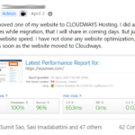](https://cdn.onlinemediamasters.com/wp-content/uploads/2021/10/Moved-to-Cloudways-Hosting-Speed.png)

[](https://cdn.onlinemediamasters.com/wp-content/uploads/2021/10/SiteGround-to-Cloudways-Results.png)

[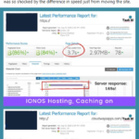](https://cdn.onlinemediamasters.com/wp-content/uploads/2021/10/Cloudways-GTmetrix-Comparison.png)

[](https://cdn.onlinemediamasters.com/wp-content/uploads/2021/10/SiteGround-To-Cloudways.png)

[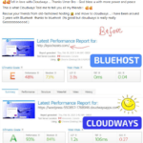](https://cdn.onlinemediamasters.com/wp-content/uploads/2021/06/Cloudways-vs-Bluehost.png)

[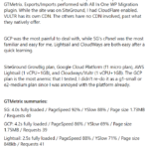](https://cdn.onlinemediamasters.com/wp-content/uploads/2021/10/Vultr-vs-SiteGround.png)

[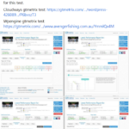](https://cdn.onlinemediamasters.com/wp-content/uploads/2021/10/WP-Engine-to-Cloudways-Migration.png)

[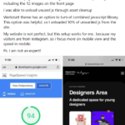](https://cdn.onlinemediamasters.com/wp-content/uploads/2021/10/Cloudways-Vultr-High-Frequency-Speed.png)

[](https://cdn.onlinemediamasters.com/wp-content/uploads/2021/10/WPEngine-to-Cloudways.jpg)

[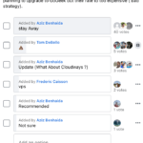](https://cdn.onlinemediamasters.com/wp-content/uploads/2021/12/Hostinger-Review-Poll.png)

[](https://cdn.onlinemediamasters.com/wp-content/uploads/2018/01/Bluehost-Managed-WordPress-Hosting.png)

[](https://cdn.onlinemediamasters.com/wp-content/uploads/2021/12/GoDaddy-Worth-It.png)

[](https://cdn.onlinemediamasters.com/wp-content/uploads/2021/12/Bluehost-vs-A2-Hosting-vs-Cloudways.png)

LiteSpeed hosting on [NameHero](https://www.namehero.com/affiliates/idevaffiliate.php?id=938&url=209" \t "_blank) is another solid choice (if you haven’t heard of LiteSpeed, go [read about it](https://www.litespeedtech.com/)). It’s cheaper than Cloudways because it’s shared hosting – but faster than most.

I’m not sure why people use other LiteSpeed hosts like Hostinger/A2 when you get more CPU cores + RAM with NVMe on NameHero. You can use the LiteSpeed Cache plugin with server-side caching, QUIC.cloud, HTTP/3, and Redis. This is arguably the fastest setup you’ll find on a budget. I don’t know anywhere else you get 3 CPU cores, 3GB RAM, and NVMe on LiteSpeed for $8/mo. [WP Johnny](https://wpjohnny.com/litespeed-cache-wordpress-plugin-unofficial-guide/) and I both have solid guides on [configuring LiteSpeed Cache with QUIC](https://onlinemediamasters.com/litespeed-cache-settings/). The main con is they only have [data centers](https://www.namehero.com/affiliates/idevaffiliate.php?id=938&url=331) in US + Netherlands. Otherwise they have [higher uptimes](https://www.namehero.com/affiliates/idevaffiliate.php?id=938&url=355) with less ‘frequent maintenance’ compared to Hostinger/A2’s uptime status page with US-based support. Ryan (the founder) is a down to earth guy if you watch his [YouTube channel](https://www.youtube.com/c/Nameherocom).

[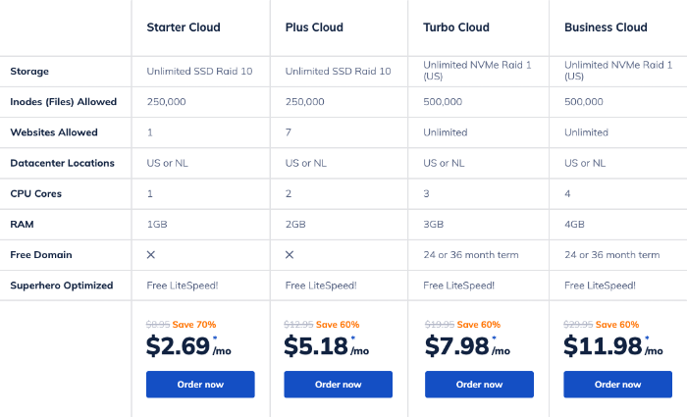](https://www.namehero.com/affiliates/idevaffiliate.php?id=938&amp;url=350)

*NameHero has more resources compared to similar LiteSpeed hosts (see*[*specs page*](https://www.namehero.com/affiliates/idevaffiliate.php?id=938&url=350)*)*

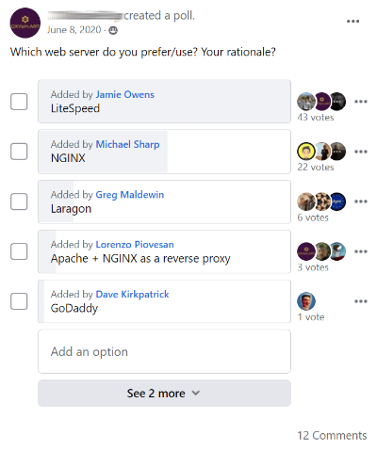

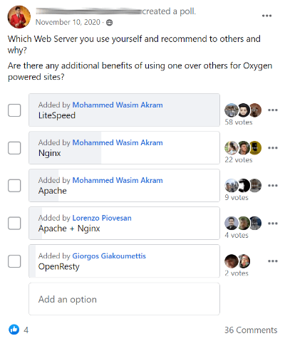











**Affiliate Disclaimer**: I use affiliate links to [Cloudways](https://www.cloudways.com/en/online-media-masters.php?id=262128" \t "_blank) + [NameHero](https://www.namehero.com/affiliates/idevaffiliate.php?id=938&url=209" \t "_blank) and appreciate your support. But what do I know? I’m just a biased affiliate. Do your own [research](https://cdn.onlinemediamasters.com/wp-content/uploads/2021/05/Cloudways-vs-SiteGround-Opinion.png) in FB groups.

**8. Add Cloudflare’s CDN**

A [CDN](https://wordpress.org/support/article/optimization/#use-a-content-delivery-network-cdn) (content delivery network) means your website is hosted on multiple data centers around the world. This reduces the [geographical distance](https://wordpress.org/support/article/optimization/#geographical-distance) between your server and visitor, while offloading resources to those data centers (lightening the load on your own server). You can even use multiple CDNs like [StackPath](https://tracking.stackpath.com/ov32O" \t "_blank) or [KeyCDN](https://www.keycdn.com/" \t "_blank) which adds even more data centers.

[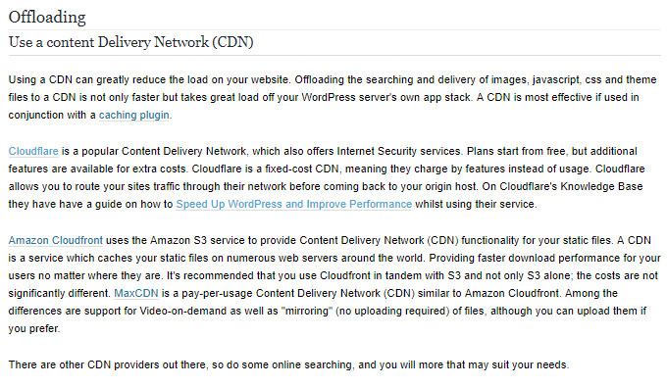](https://wordpress.org/support/article/optimization/#use-a-content-delivery-network-cdn)

[Cloudflare](https://www.cloudflare.com/) is free and has [250+ data centers](https://www.cloudflare.com/network/) which is well over most premium CDNs.

**Step 1**: Check if your host lets you enable Cloudflare in your account. If they do, activate Cloudflare then you’re done. If they don’t, you’ll need to change nameservers starting in step 2.

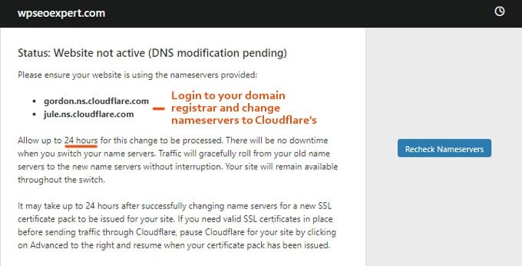

**Step 2**: Sign up for Cloudflare, choose the free plan, add your website, then let Cloudflare run their scan. Cloudflare will walk you through a set of pages until they assign you 2 nameservers.

**Step 3**: Login to your domain registrar and find the option to set custom nameservers (Google “custom namesevers on XYZ hosting company)”. Replace those nameservers with Cloudflare’s.

**9. Disable Hotlinking**

If you have high quality images on your website, people might be “borrowing” them to use on their own site. But instead of saving and uploading the images, people will copy/paste them from your site to theirs. This means you are hosting those images on your server (not good).

You can enable hotlink protection in [Cloudflare](https://support.cloudflare.com/hc/en-us/articles/200170026-What-does-enabling-Cloudflare-Hotlink-Protection-do-) or often times, in your [hosting account](https://www.siteground.com/kb/hotlink-protection/). This prevents people from using up your precious server resources by copying/pasting your images.



**10. Minify Files**

GTmetrix tells you to minify HTML, CSS, and JavaScript files.

Your cache plugin should take care of this (if not, make sure their settings are enabled).

**11. Combine Files**

If you have multiple CSS or JavaScript files, try combining in them into 1 single file.

The less CSS and JavaScript files you have, the less requests will be loaded on your website.

**Step 1**: Find your CSS (or JavaScript files).

**Step 2**: Copy/paste the contents so they’re all in one file.

Or, most cache plugins have an option to combine CSS + JavaScript:



**12. Avoid Heavy Plugins**

If you’re using WordPress plugins, Joomla Extensions, or any “add-ons” that add functionality to your website, make sure they don’t add to your load times (use GTmetrix for benchmarks).

The most common slow plugins are related to portfolios, sliders, social sharing, page builders, live chat, calendars, statistic (analytics), contact form, or related post plugins.

**How To Find Slow Plugins On Your Website**  
If you see the same plugin showing up multiple times in your GTmetrix report, and it has high load times in your Waterfall tab, consider deleting it and replacing it with a more lightweight plugin. For WordPress, you can also use [Query Monitor](https://wordpress.org/plugins/query-monitor/) to see your slowest loading plugins.

**Which Plugins To Avoid**  
See these [70+ slow WordPress plugins](https://onlinemediamasters.com/slow-wordpress-plugins/) for the full list.

1. AddThis
2. AdSense Click Fraud Monitoring
3. All-In-One Event Calendar
4. Backup Buddy
5. Beaver Builder
6. Better WordPress Google XML Sitemaps
7. Broken Link Checker
8. Constant Contact for WordPress
9. Contact Form 7
10. Contextual Related Posts
11. Digi Auto Links
12. Disqus Comment System
13. Divi Builder
14. Elementor
15. Facebook Chat

**Bonus: Selectively Disable Plugins**  
Use a plugin like [Assets Manager](https://wordpress.org/plugins/gonzales/) to selectively disable plugins from running on certain pages. For example, if you only use your contact form on the contact page, disable it everywhere else.

**13. Clean Your Database**

As you update posts, install and delete plugins, or perform other tasks on your website, this will start to accumulate bloat in your database. It’s best to clean it once every 2 weeks or so.

You can clean your database using the free [WP-Optimize plugin](https://wordpress.org/plugins/wp-optimize/), or use WP Rocket:

[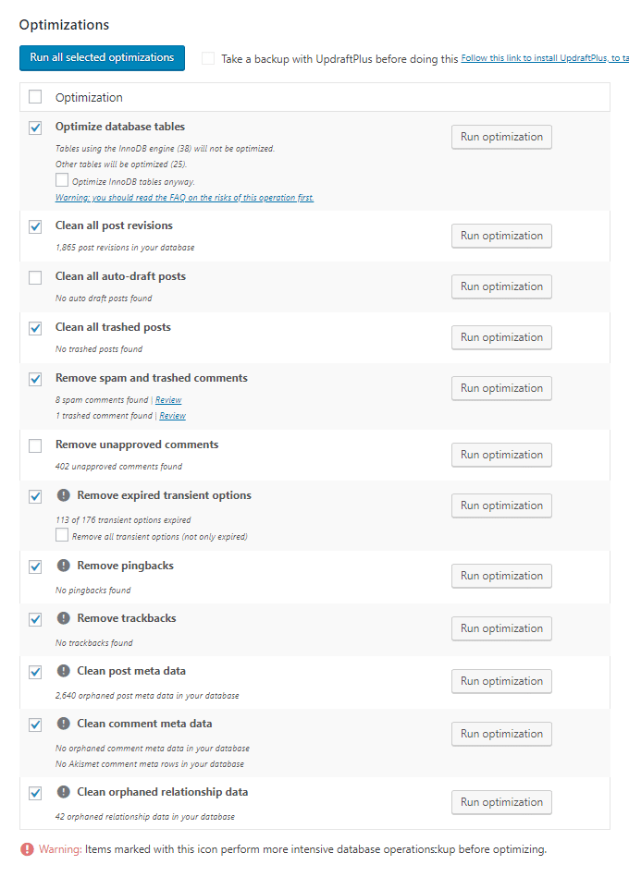](https://wordpress.org/plugins/wp-optimize/)

**14. Optimize External Resources**

[External resources](https://kinsta.com/blog/third-party-performance/) are anything from embedded YouTube videos to Google Fonts, Google Analytics, Gravatars, and anything requiring information to be pulled form an outside website. These can destroy your GTmetrix report, especially Google AdSense as it runs on every page.

**Tips For Optimizing External Resources**

* **Disques** – use [conditional load](https://wordpress.org/plugins/disqus-conditional-load/).
* **Contact Form 7 Asynchronous Loading** – load it [asynchronously](https://contactform7.com/loading-javascript-and-stylesheet-only-when-it-is-necessary/).
* **Google AdSense** – use [Ad Balancer](https://support.google.com/adsense/answer/7215246?hl=en) and [Cloudflare Rocket Loader](https://support.cloudflare.com/hc/en-us/articles/200168056-What-does-Rocket-Loader-do-).
* **Google Analytics** – host it locally using [WP Rocket](https://docs.wp-rocket.me/article/1103-google-tracking-add-on) or [CAOS Analytics](https://wordpress.org/plugins/host-analyticsjs-local/).
* **Google Maps** – only use them on pages where you need them (eg. contact form)
* **Google Fonts** – combine Google Fonts in WP Rocket, Autoptimize, or try [Self-Hosted Google Fonts](https://wordpress.org/plugins/selfhost-google-fonts/)/[OMGF](https://wordpress.org/plugins/host-webfonts-local/). Or, [host fonts locally](https://transfonter.org/) by downloading them directly from Google Fonts, converting them to web font files in [Transfonter](https://transfonter.org/" \t "_blank), then adding them to your CSS.
* **Gravatars** – try [Optimum Gravatar Cache](https://wordpress.org/plugins/optimum-gravatar-cache/), [FV](https://cn.wordpress.org/plugins/fv-gravatar-cache/), [Harrys](https://en-nz.wordpress.org/plugins/harrys-gravatar-cache/), or [WP User Avatar](https://wordpress.org/plugins/wp-user-avatar/).
* **Async JavaScript** – try [Aysnc JavaScript](https://wordpress.org/plugins/async-javascript/" \t "_blank) to load other scripts asynchronously.
* **Embedded YouTube Videos** – lazy load videos and replace iframes with preview images using WP Rocket (in the media section), or use the [WP YouTube Lyte plugin](https://wordpress.org/plugins/wp-youtube-lyte/).
* **Prefetching** – this helps browser anticipate external resources. Copy these [common domains to prefetch](https://gist.github.com/lukecav/9931c3f6e402e23f58065d6b2665ef5b) then paste them into WP Rocket, Perfmatters, or [do it manually](https://www.keycdn.com/support/prefetching).
* **Selectively load plugins using external scripts** – use [Asset Cleanup](https://wordpress.org/plugins/wp-asset-clean-up/) or [Perfmatters](https://perfmatters.io/docs/disable-scripts-per-post-page/" \t "_blank) to disable plugins (especially those with external scripts) from loading on certain content.

**15. Combine Google Fonts**

Are you using Google Fonts, Font Awesome or other external fonts?

These will probably cause extra requests in GTmetrix since they are an external resource.

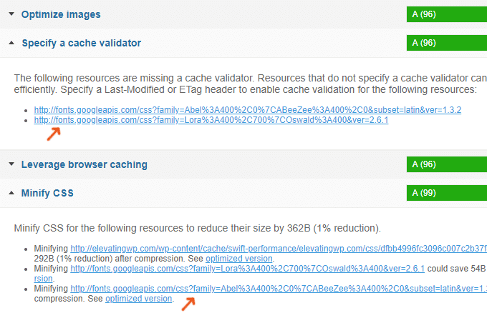

**Tips For Optimizing Google Fonts**

* [Host Google Fonts locally](https://onlinemediamasters.com/load-google-fonts-locally-wordpress/)
* Only select fonts/weights you need
* Combine multiple font files into 1 file (manually or via WP Rocket or Autoptimize)

**16. Lazy Load Images + Videos**

Lazy loading means images, videos, and iframes are only loaded once users scroll down the page and actually see them. This can significantly improve the initial load times of your pages.

Embedded videos can be one of the heaviest elements on a page – lazy loading 2 videos (and replacing the iframe with a preview image) shaved a whopping 4 seconds off one of my posts.

For WordPress, you can use WP Rocket, WP YouTube Lyte, or the Lazy Load plugin.

For Squarespace, try this [Lazy Load feature](https://squarestud.io/products/lazy-load).

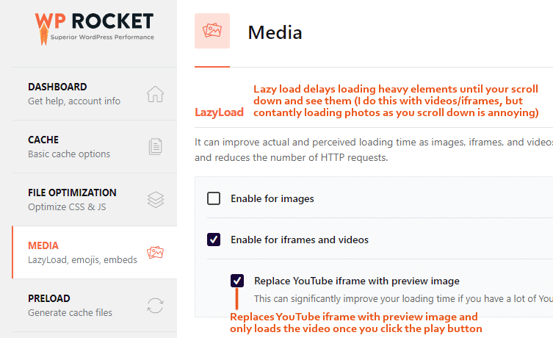

**17. Avoid Advertisements**

Google AdSense is notorious for making websites load slow, and it’s not even that profitable. You can try [Ad Balancer](https://support.google.com/adsense/answer/7215246?hl=en) and [Rocket Loader](https://support.cloudflare.com/hc/en-us/articles/200168056-What-does-Rocket-Loader-do-), but you will have many errors in your GTmetrix report regardless and are better off [monetizing with affiliate marketing](https://onlinemediamasters.com/how-to-make-money-with-affiliate-marketing/). Forget AdSense – most successful people making $50k+ are using affiliate links which don’t slow down your site.

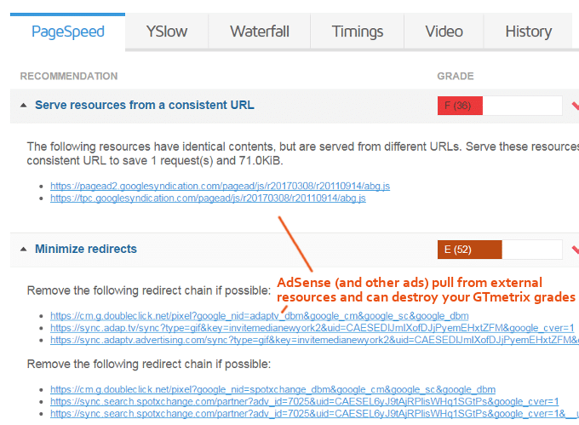

**18. Consider AMP**

[AMP](https://amp.dev/) (accelerated mobile pages) make your mobile pages load faster while giving you an AMP stamp in mobile search results. The problem is, this changes the design of your mobile pages. You can use the [AMP for WP plugin](https://wordpress.org/plugins/accelerated-mobile-pages/) to customize them, but it’s just not the same. [Kinsta’s conversions dropped 58%](https://kinsta.com/blog/disable-google-amp/" \t "_blank) when adding AMP, so I actually decided to disable them on my own site. But it’s worth considering. Here’s an [AMP tutorial for Squarespace](https://support.squarespace.com/hc/en-us/articles/223766868-Using-AMP-with-Squarespace) if you’re using that.

**19. Find Slow Pages In Google Analytics**

You can find your slowest loading pages in [Google Analytics](https://support.google.com/analytics/answer/1205784?hl=en) under **Behavior → Site Speed → Speed Suggestions**.

Most often, these pages load slow because they have lots of images, videos, or external resources. That’s because most speed factors apply to your entire website, not just 1 page.

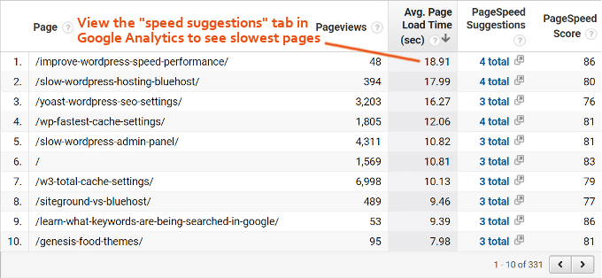

**20. WordPress-Specifics Optimizations**

I’ve already covered quite a few [WordPress-specific optimizations](https://onlinemediamasters.com/slow-wordpress-site/), but here are a few more.

[](https://onlinemediamasters.com/slow-wordpress-site/)

* Use a top-rated cache plugin like WP Rocket
* Use a good image optimization plugin like ShortPixel
* Use the Heartbeat Control plugin to disable Heartbeat API
* Delete all plugins you’re not using and use lightweight plugins
* Clean your database frequently using WP-Optimize or WP Rocket
* Cache Gravatars using a plugin like Harrys Gravatar Cache, FV, or Optimum
* Use Asset Manager to selectively disable plugins from loading on certain pages
* Host Google Analytics locally using a plugin like WP Rocket or CAOS Analytics
* Host Google Fonts locally using a plugin like OMGF or Self-Hosted Google Fonts

**21. WooCommerce Optimizations**

By default, [WooCommerce](https://onlinemediamasters.com/speed-up-slow-woocommerce-store/) adds extra scripts, styles, and cart fragments to your website. They also typically require more plugins. That’s why when choosing a hosting plan, you probably want to go VPS, cloud, or semi-dedicated hosting to ensure it can handle the extra resource consumption. Otherwise on shared hosting, you may end up exceeding your host’s CPU limits.

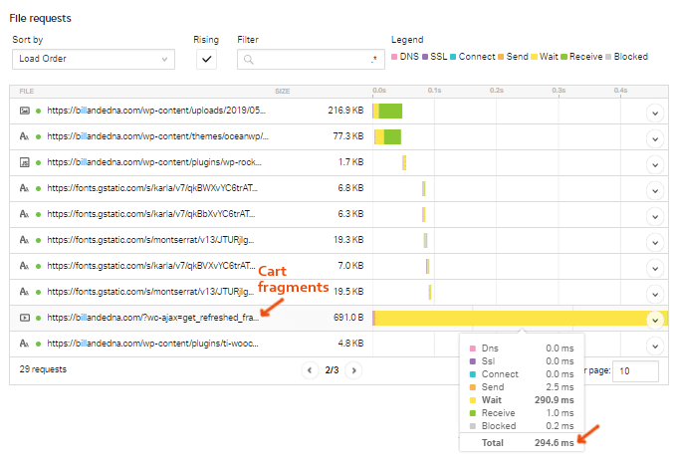

**Disable Cart Fragments** – cart fragments update the items and total in the cart, but they can take anywhere from 1 second to as long as 10 seconds to load. Your best bet is to [disable cart fragments on the homepage + posts](https://www.webnots.com/fix-slow-page-loading-with-woocommerce-wc-ajaxget_refreshed_fragments/), since that’s where they’re not used. Follow that tutorial.

**Disable WooCommerce Scripts** – WooCommerce can also load around 8 different scripts on your website. To disable these, grab this [code from Github](https://gist.github.com/DevinWalker/7621777) and add it to your functions.php file.

**Disable WooCommerce Styles** – WooCommerce also has styles that load on every single page. Here is a [guide for disabling them](https://docs.woocommerce.com/document/disable-the-default-stylesheet/).

**Perfmatters** – this nifty plugin by Kinsta makes it easy to disable cart fragments, scripts, and styles. If you want an easy way to disable them without editing code, try this premium plugin.

**Clear Customer Sessions** – if your WooCommerce site is slow, try clearing customer sessions.

**Increase Memory Limit to 256MB** – WooCommerce requires you to increase your memory limit to 256MB, but you should really do this for most websites. Here’s a [tutorial](https://docs.woocommerce.com/document/increasing-the-wordpress-memory-limit/) for doing that.

**22. Hire Someone Who Knows What They’re Doing**

Need help fixing your slow loading website?

I work with a few developers who specialize in [WordPress speed optimization](https://onlinemediamasters.com/wordpress-speed-optimization/). You can check out their portfolio on that page, and I credit them to getting my GTmetrix scores to 100%. Cole manages all speed optimization projects, you can reach him at cole@onlinemediamasters.com.

**23. Frequently Asked Questions**

**What factors have the biggest impact on load times?**

Choosing the right hosting, plugins, and cache plugin can have a highest impact on your load times. Optimizing images and avoiding external resources like Google AdSense are also very important. Using a free content delivery network like Cloudflare will also help.

**Which tool is best for testing speed?**

GTmetrix has the most robust recommendations out of all speed testing tools. Google PageSpeed Insights is primarily good for 1 thing - measuring server response times.

**How can I tell what's slowing down my website?**

GTmetrix tells you which images need to be optimized, whether you're using a CDN, and plugins that may appear multiple times in your report or in your GTmetrix Waterfall. It also measures time to first byte which is a good indicator of whether your hosting is slow.

**What are some lesser-known speed tips?**

Many people don't upgrade their PHP version or optimize external resources like Google Fonts and YouTube videos. Lazy load images and videos, and hosting Google Fonts and Google Analytics locally can fix many items in GTmetrix. You should also join Facebook Groups to get unbiased opinions about the best hosting providers, to avoid affiliate traps.

**Which hosting is best?**

Cloudways was rated highly in Facebook polls and has a great reputation in Facebook Groups.

**Which cache plugin is best?**

WP Rocket was rated the #1 cache plugin in multiple Facebook polls, since it comes with many speed optimization features most cache plugins don't (lazy loading, database cleanup, hosting Google Fonts and Google Analytics locally). You should get optimal results with WP Rocket, otherwise Swift Performance is a good free plugin alternative.

I really hope this tutorial was helpful. If you need help, leave your GTmetrix report in the comments and I’ll hit you up with a few suggestions. Or consider hiring my speed optimizer.

Cheers,  
Tom

3. Inaccurate information on a website

* [**INTERNET**](https://www.wikihow.com/Category:Internet)
* [**INTERNET SECURITY**](https://www.wikihow.com/Category:Internet-Security)

[**How to Avoid False Information on the Internet**](https://www.wikihow.com/Avoid-False-Information-on-the-Internet)

[**Download Article**](https://www.wikihow.com/Avoid-False-Information-on-the-Internet)

**STEPS**

[**Steps**](https://www.wikihow.com/Avoid-False-Information-on-the-Internet#Steps)

**OTHER SECTIONS**

[**Questions & Answers**](https://www.wikihow.com/Avoid-False-Information-on-the-Internet#qa_headline)

[**Tips and Warnings**](https://www.wikihow.com/Avoid-False-Information-on-the-Internet#tips)

[**Related Articles**](https://www.wikihow.com/Avoid-False-Information-on-the-Internet#relatedwikihows)

[**Author Info**](https://www.wikihow.com/index.php?title=Avoid-False-Information-on-the-Internet&action=credits)

[**Last Updated: May 9, 2022** **Tested**](https://www.wikihow.com/Avoid-False-Information-on-the-Internet)

The Internet is a complex and dynamic landscape full of all sorts of information. Unfortunately, some of it isn't that great. It can be difficult to distinguish between good and bad sources of information, but learning to look for some signs and guideposts of bad information can make your search less complicated.

**Steps**[**Download Article**](https://www.wikihow.com/Avoid-False-Information-on-the-Internet)

**1**

**Use "common" sense.** This will allow you to filter information that is incorrect from the correct.

**2**

**Cross-check.** Reading from more one source allows for correcting mistakes, errors, and malicious intent.

**3**

**Go to the source.** Using a real library, real people, and your legs can be steps in gathering information that is free from errors.

**4**

**Take a look at the pictures.** If you are searching an online animal site, look at the pictures. You should see pictures that look real. There shouldn't be anything that looks fake or anything that seems fake.

**5**

**Look over at the policies.** Every website must have policies, rules, and promises for there site. Read them very carefully. There could be tricks people add.

**6**

**Have an adult help.** If you are a teenager or kid and are positive if a site is right or not the best choice is to have an adult, teacher, or guardian help out. It's the best choice.